**CREATE A PUBLIC BUCKET IN AWS.UPLOAD A FILE AND GIVE THE NECESSARY PERMISSION TO CHECK WHETHER THE FILE URL IS WORKING OR NOT.**

**Visit** **aws.amazon.com** **and Sign in.Click on the search field and type “s3” in the search field and select S3**

**Click on “Buckets”**

**1.….**.

**2.**

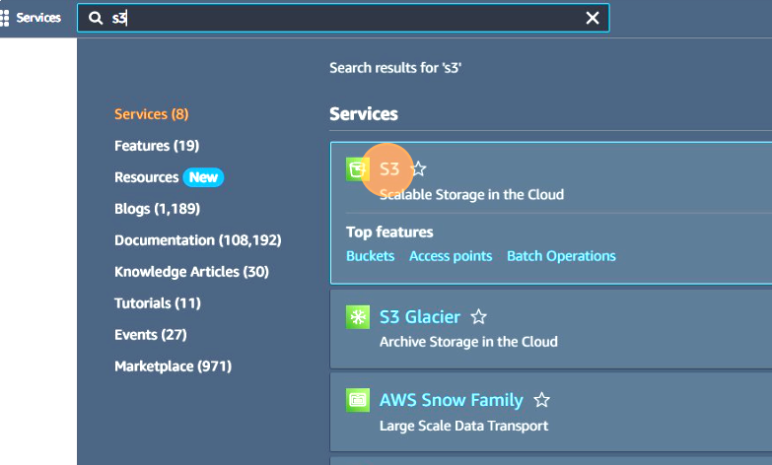

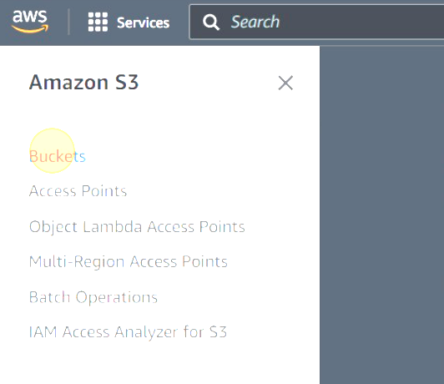

**Click the "Bucket name" field and type "hiteshpublicbucket".**

**Click on “Create Bucket”**

**s**

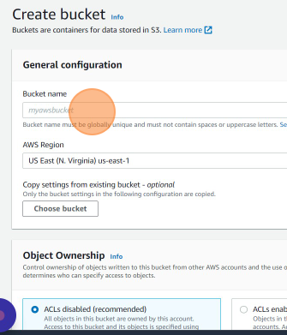

**3.**

**4.….**.

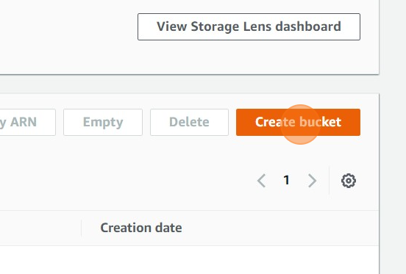

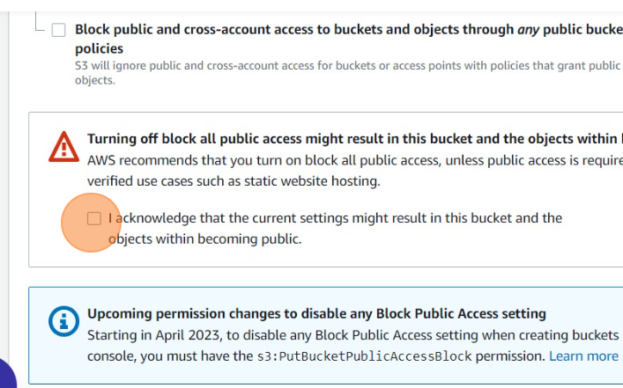

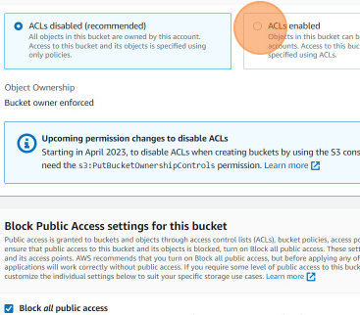

**Select ACLs enabled and uncheck “Block all public access”**

**Click on this check box**

**5.….**.

**6.**

**Click on “Create bucket”**

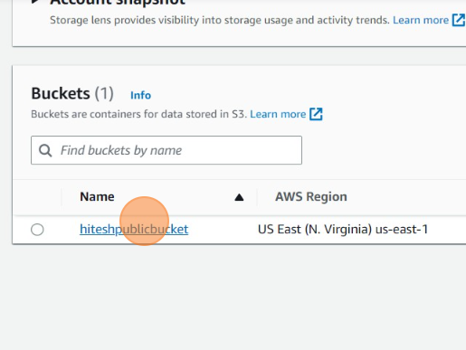

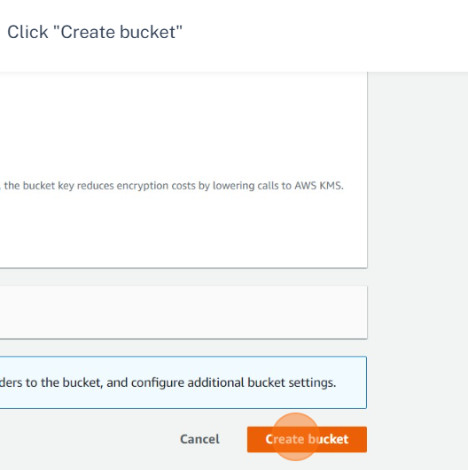

**Click on “hiteshpublicbucket”**

**7.….**.

**8.**

**10.**

**Add files and folders which you want to upload and click upload**

**S** 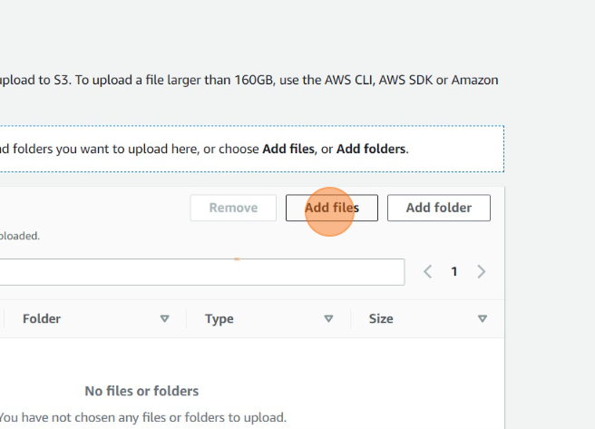

**Click on “Upload”**

**9.**

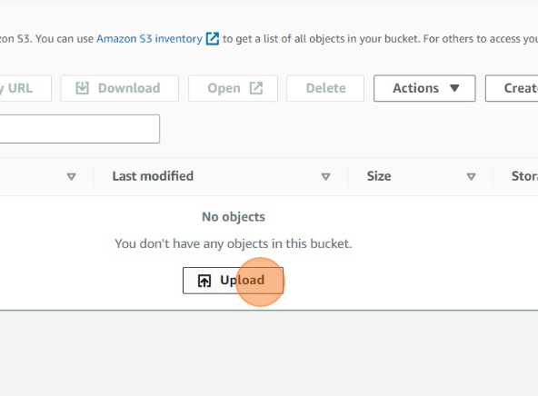

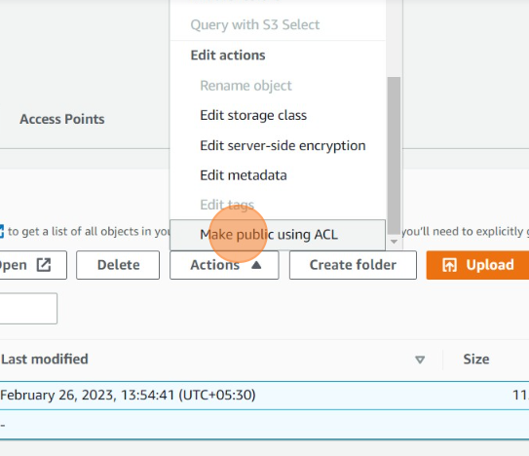

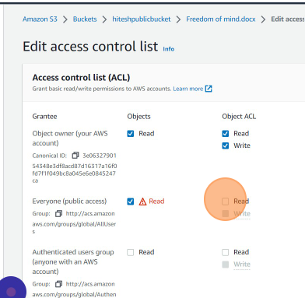

**Select the file click “Action”. Click on “Make public using ACL” and then click on make public.**

**12.**

**You may click the filename and then go to permission and select edit and allow everyone to access the file. Acknowlegde and then save changes.**

**11.**

**or**

**Now the file is accessible through both the object URL and the presigned URL.**

**13.**

**.**